Create a resource group in Azure and create following services in azure

1. ADLS Storage account
2. Blob Storage Account
3. SQL Database
4. Azure Data Factory

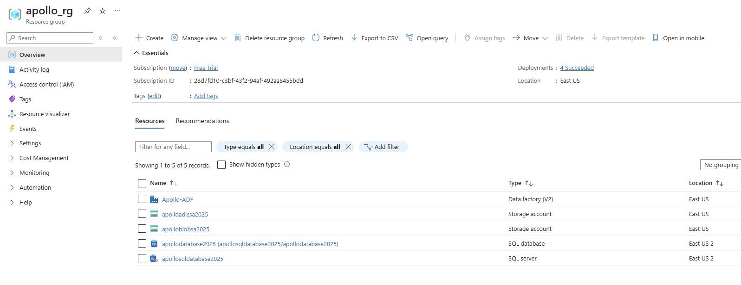

**Project Architecture:**

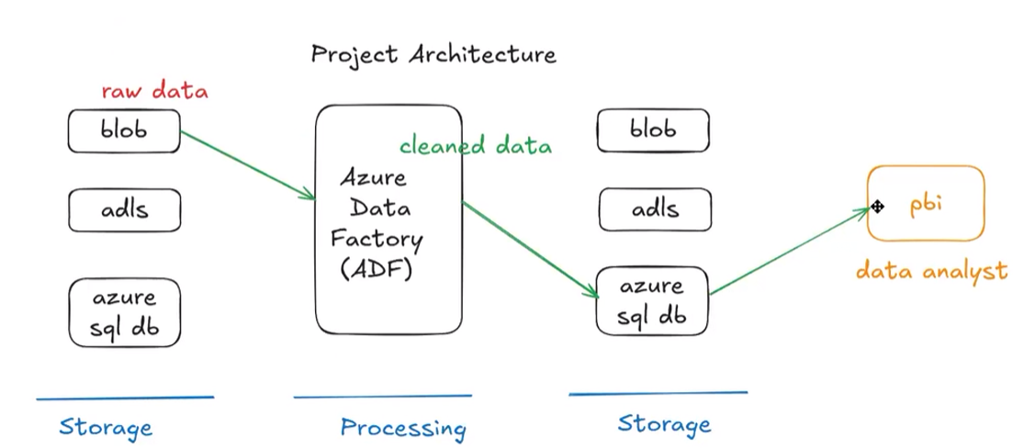

**Medallion Architecture Implementation:**

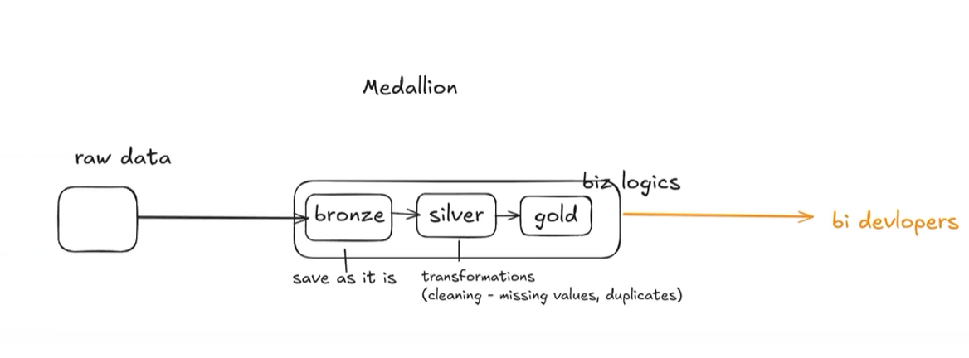

**Client sent the files on Azure blob storage account from different source and in different file format.**

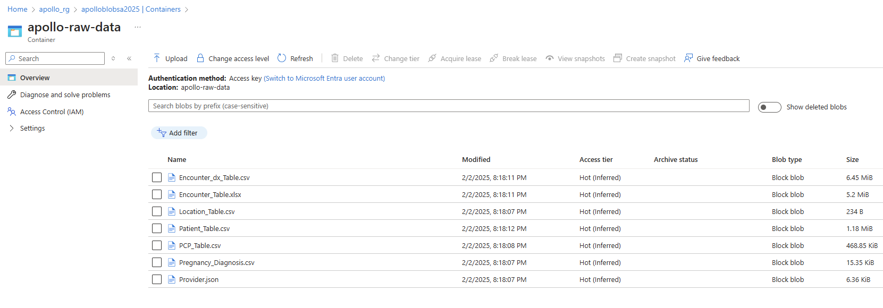

We will be using the ADLS storage account further, where we will copy this raw data using ADF and store it in organized way.

Create the container name with Apollo-adls and create directory names as bronze, silver, gold inside it to follow medallion architecture.

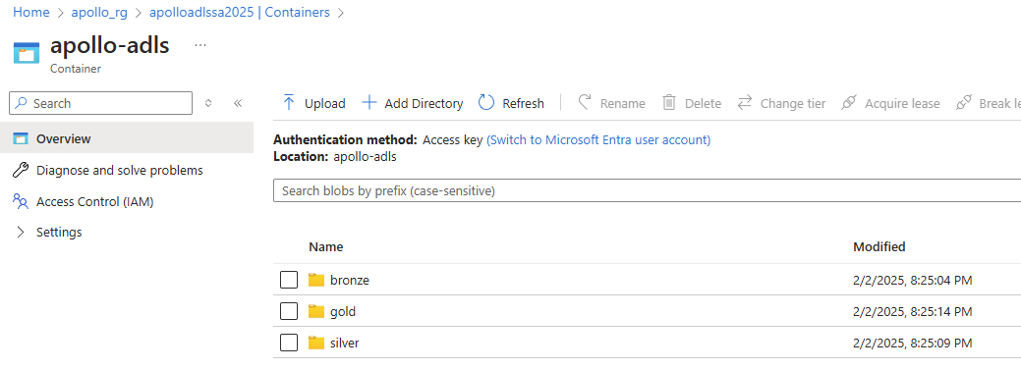

Launch the Azure Data Factory UI to do the ETL process:

**Implementation Steps:**

**Step 1: Create Linked Services, Datasets, Pipelines, and Dataflows**

* We will start by creating the necessary linked services, datasets, pipelines, and dataflows required for the project.

**Step 2: Data Ingestion (Bronze Layer)**

* First, we will extract the data by copying it from raw storage to the Bronze layer. This layer stores raw, unprocessed data as it is ingested.

**Step 3: Data Cleaning and Transformation (Silver Layer)**

* Next, we will clean and transform the data. This includes handling missing values and duplicates. The cleaned and enriched data will be stored in the Silver layer, which ensures schema validation and standardization.

**Step 4: Data Aggregation and Loading (Gold Layer)**

* Finally, we will aggregate the cleaned data and load it into the Gold layer as business-ready data. Additionally, we will load the cleaned data into an SQL database for further use by Data Analytics and Data Science teams.

**Steps to create the ETL in ADF:**

Step1: Copy the data from raw to bronze. Create a ADF pipeline named as *Raw2Bronze_PL.*

In Move and Transform Activities, drag copy data into white board. And define the source and sink. Where required create a link service.

Link service:

Datasets: rawdatafiles

In pipeline:

🡪 Source: use * to fetch all files

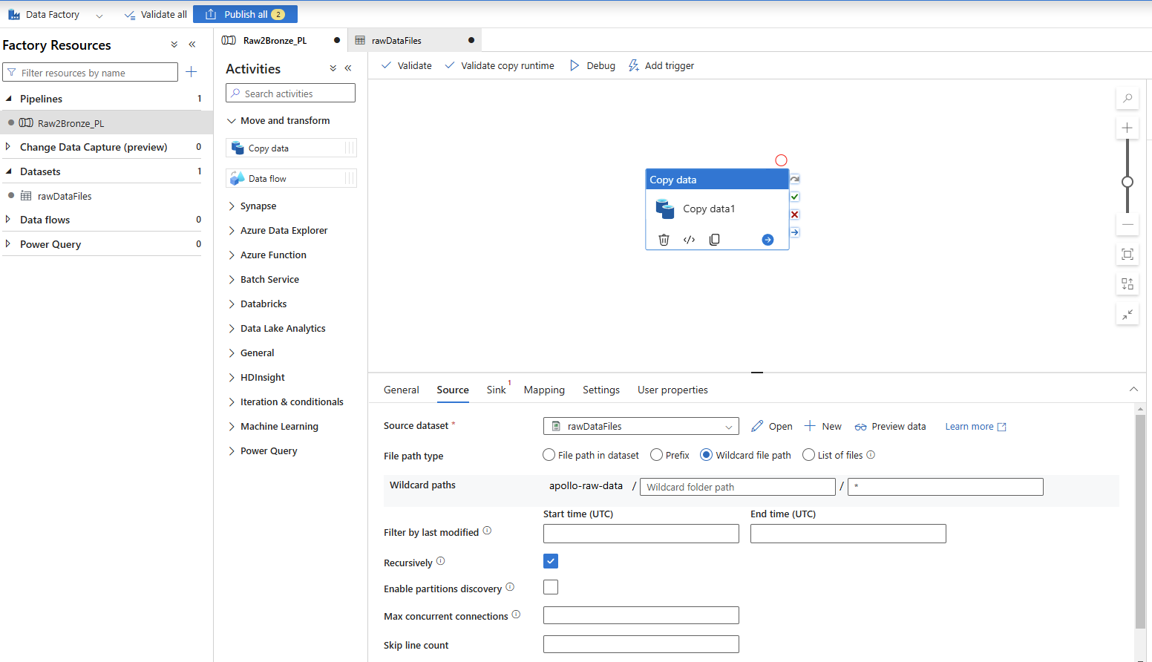

Sink:

Dataset: BronzeDataFiles

Ls: adls2adf_ls

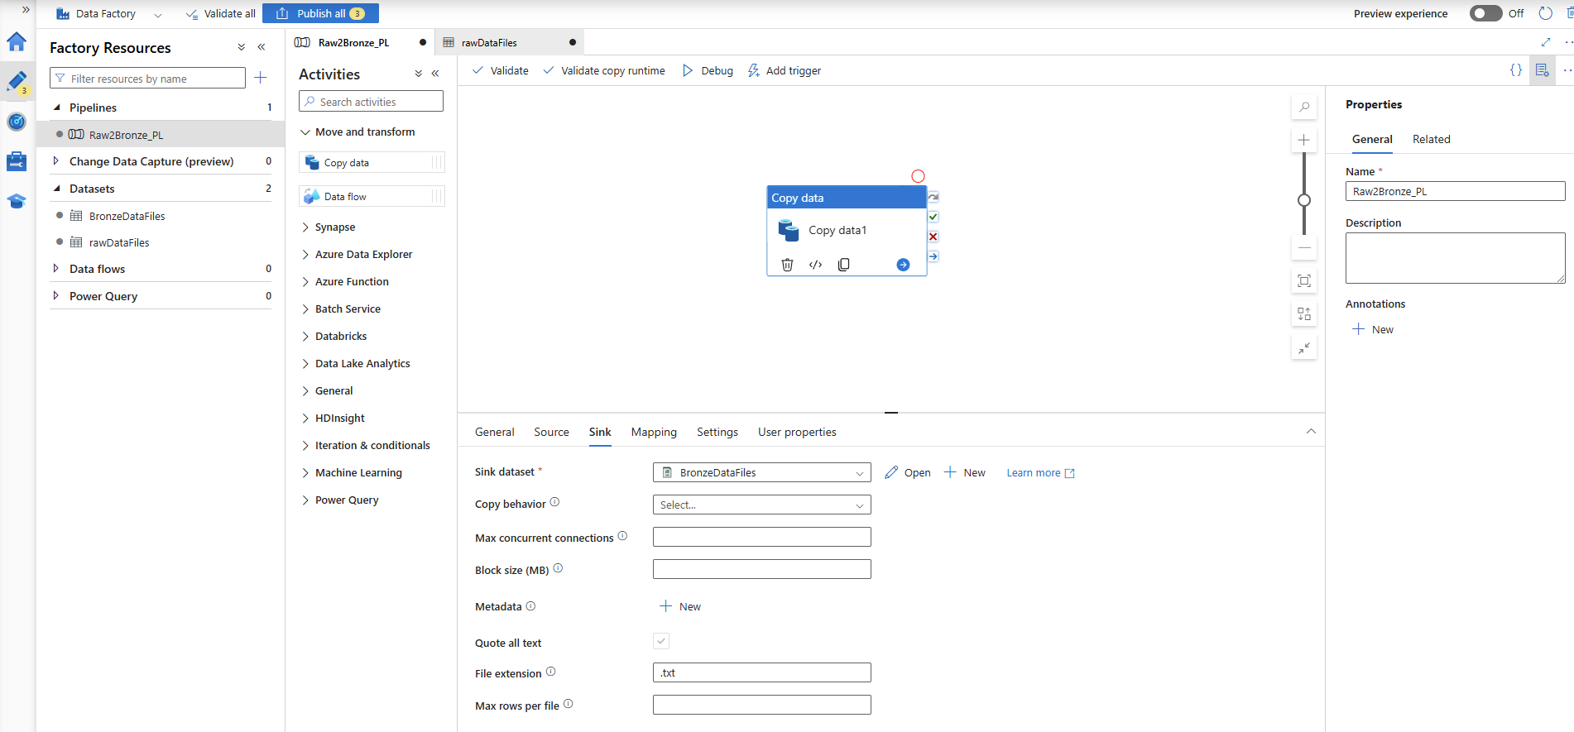

Now trigger/debug the pipeline.

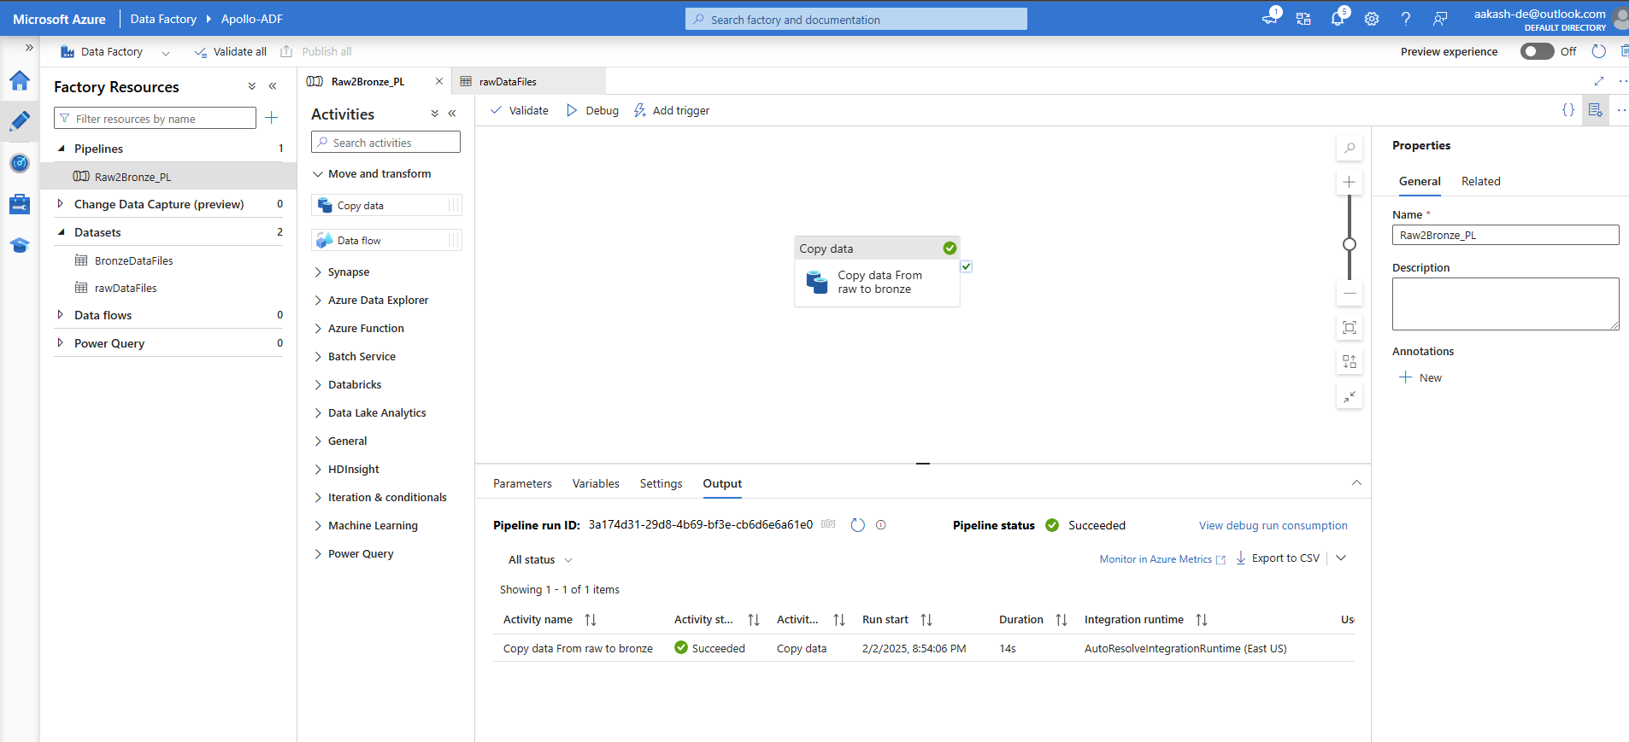

Post completion, files will move to bronze

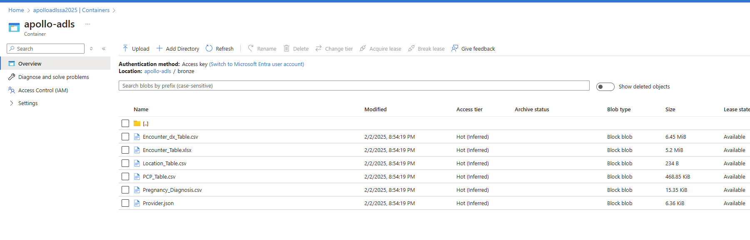

Now from bronze we will pick the file one by one and process it.

Create 1st Dataflow followed by dataset. Also enable the Debug mode to preview data.

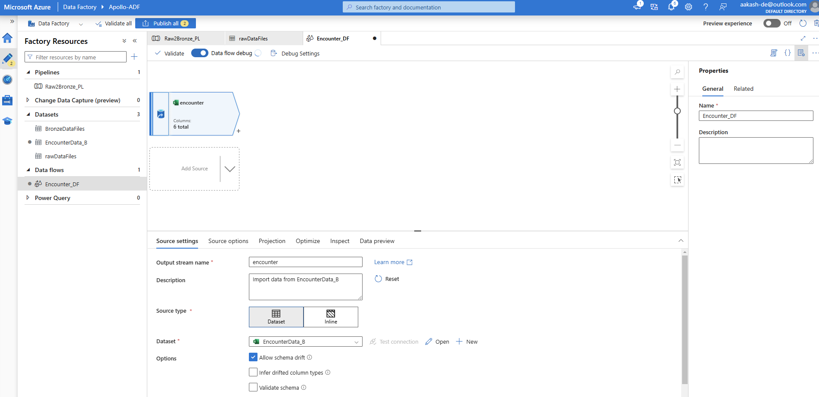

In the encounter data set. In column enc_status, there is two status of completed (Compeleted and Completed). Hence to fix it derive a column and correct it.

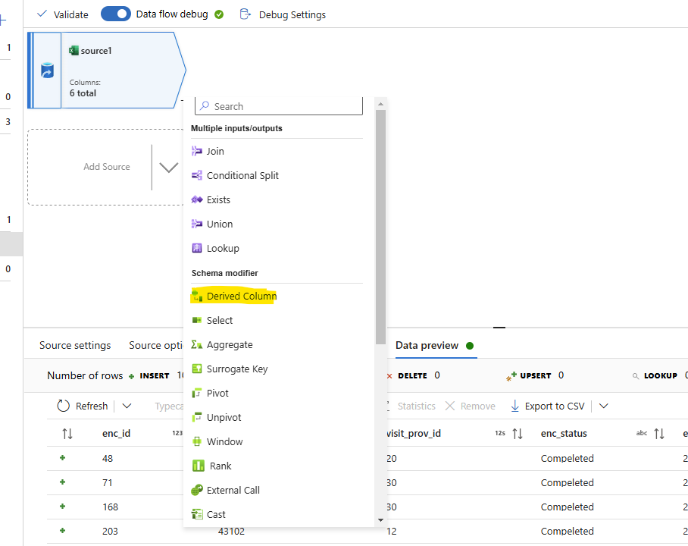

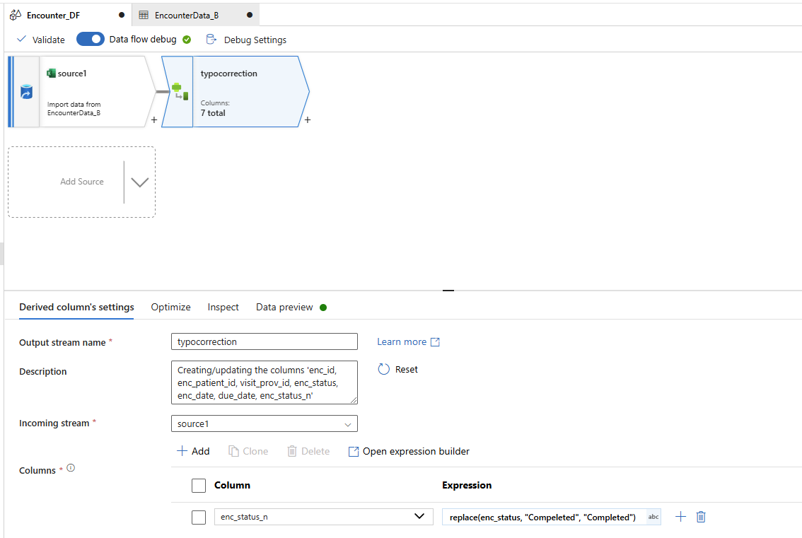

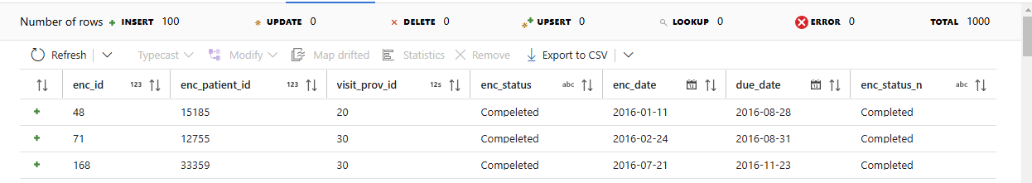

Remove the column enc_status and rename enc_status_ to enc_status. For this click on + sign and select

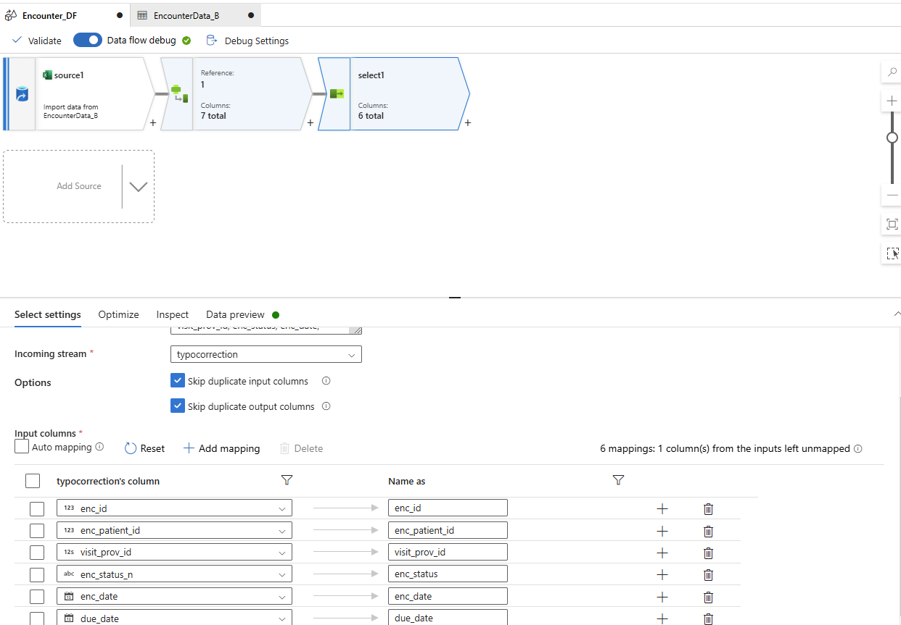

Now as the cleaning is done, sink the dataset. For it create a new dataset and sink into it to push it into the silver layer. We will make sure the file format is same for all file so select the csv file format.

In setting make sure you select the pattern and then give file name.

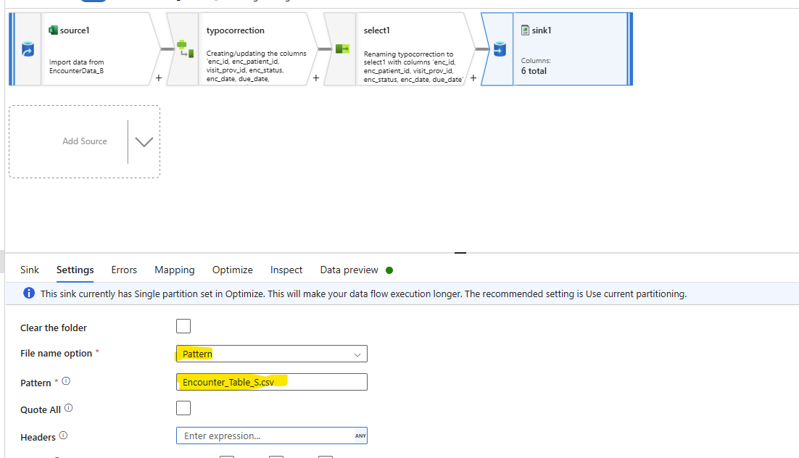

And in optimize select the single partition

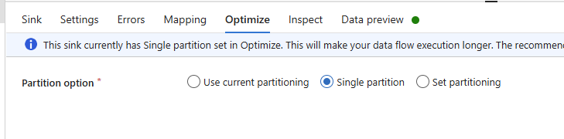

Publish it.

Now as we had created a data flow. To trigger it create a new pipeline names as bronze2silver_PL and select DataFlow from move and transform.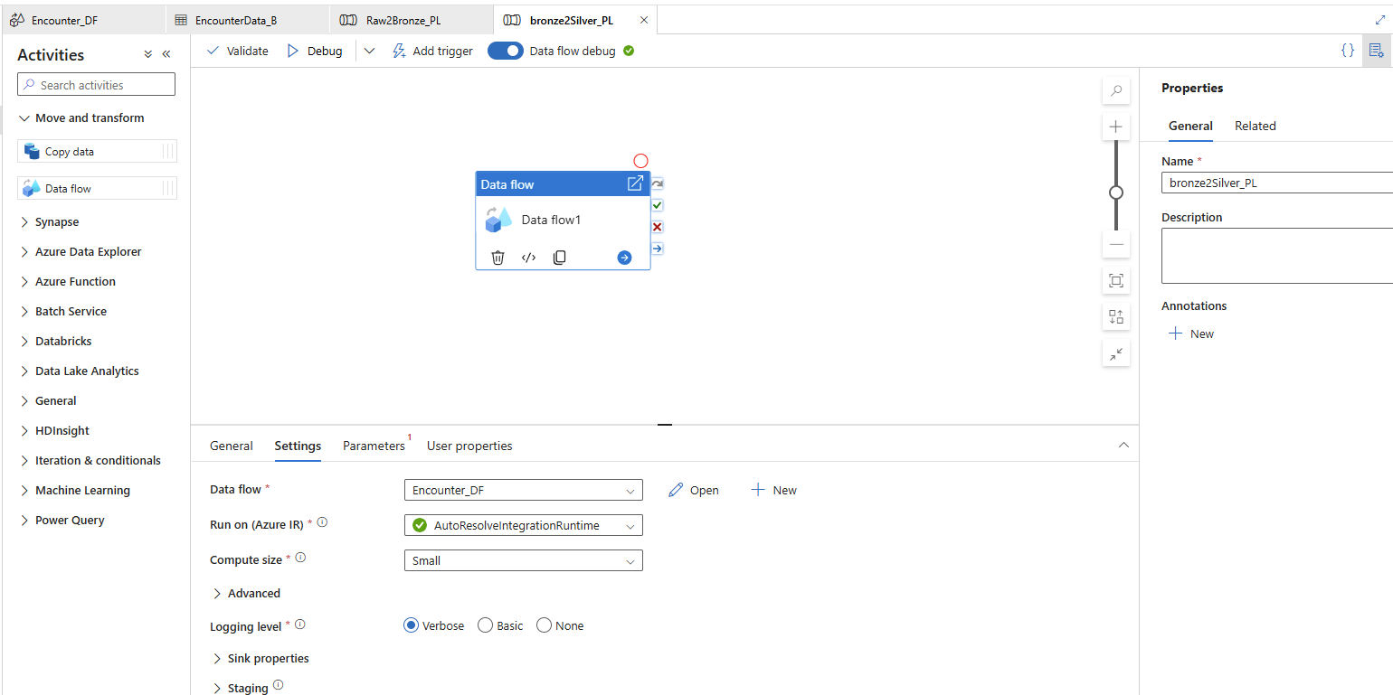

Trigger it now.

After it completed check and logs and validate the files in container.

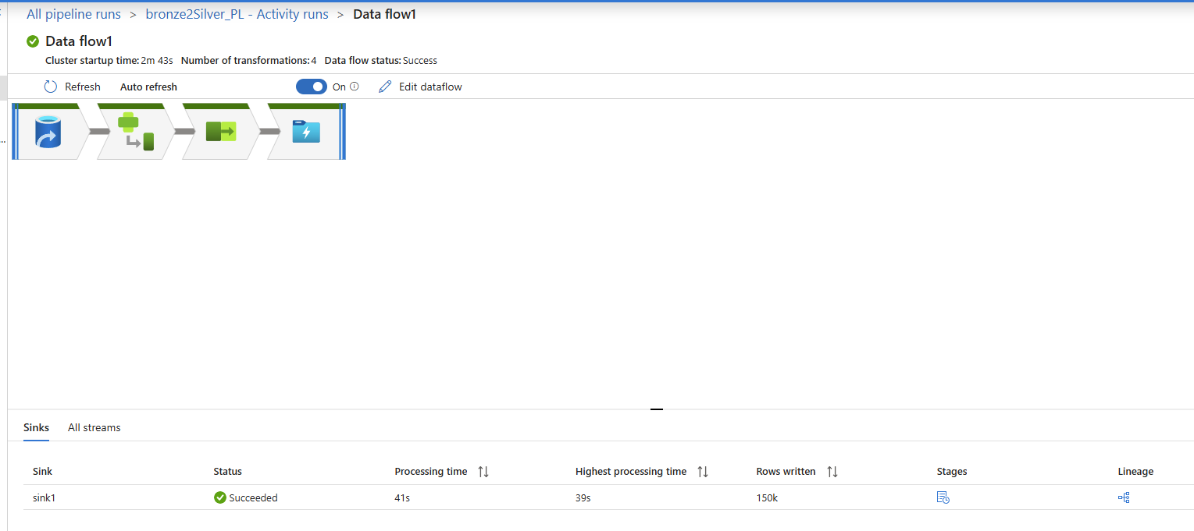

Now move to next file encounter_dx_Table.csv.

For this create a new dataflow. Similary as above create a new dataset and create the dataflow activity.

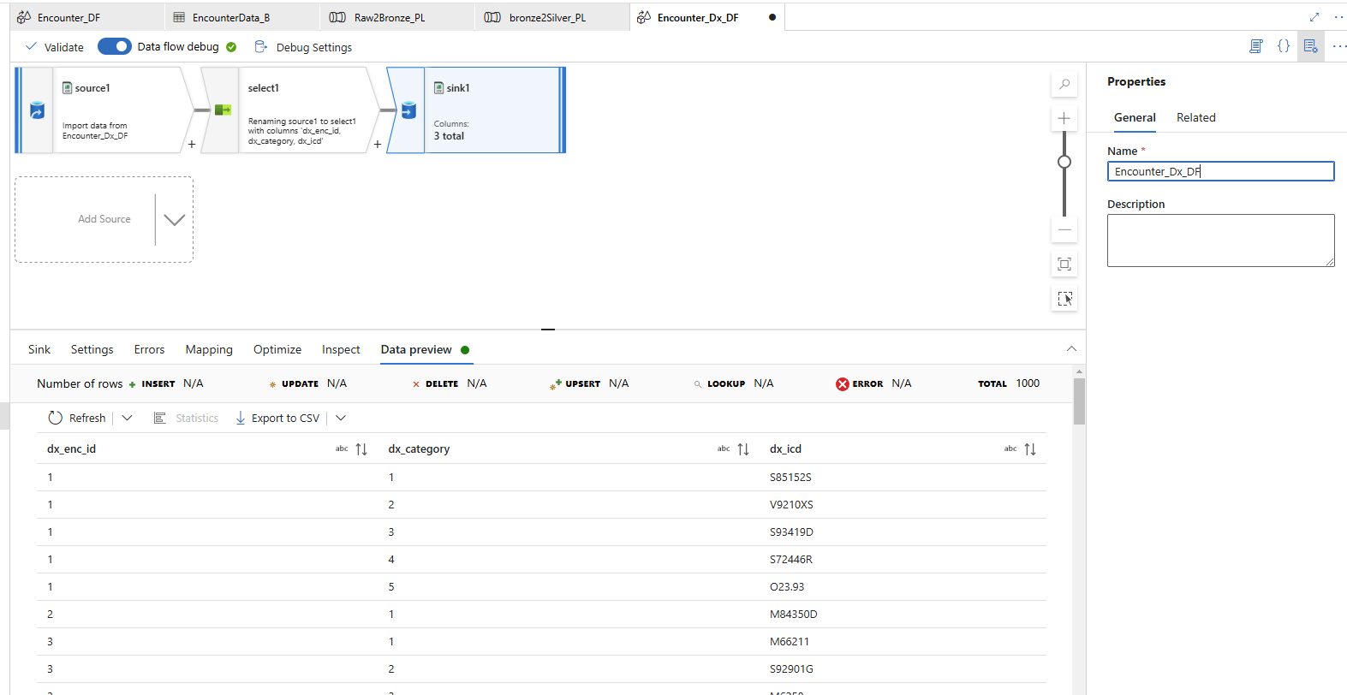

Also create a dataflow for providers. It is JSON format, so select accordingly while creating the dataset. To make data set read the JSON format make changes in Source Options

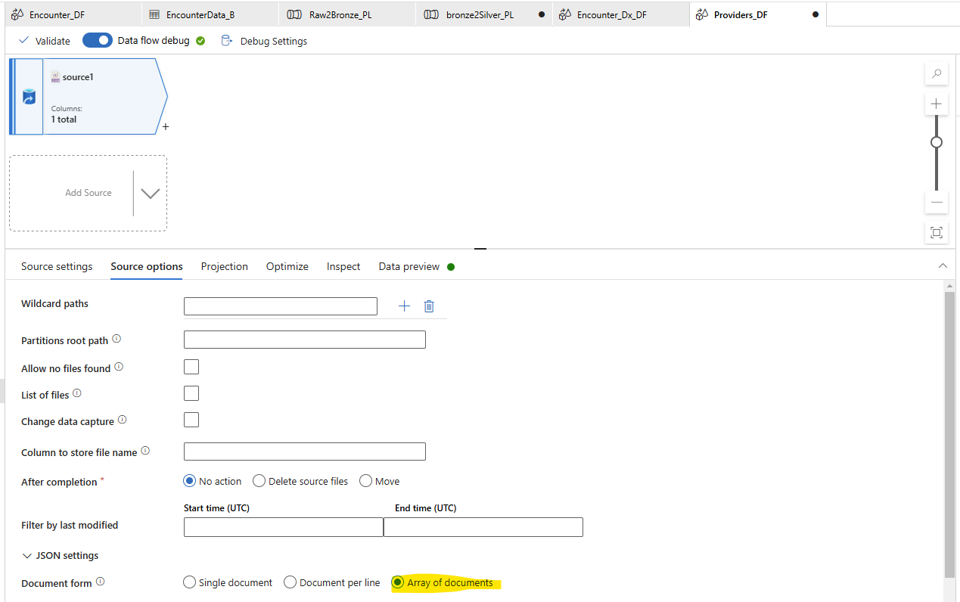

And in Projection, import the projections. Still it will give error.

Because it is in Sheet1

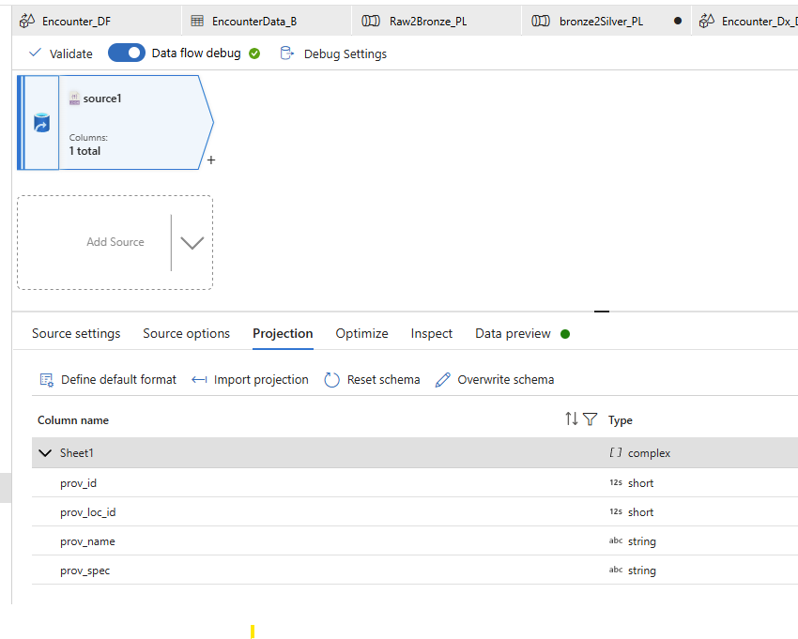

To fix it we need to add the Activity as Flatten to go 1 step down and get the schema.

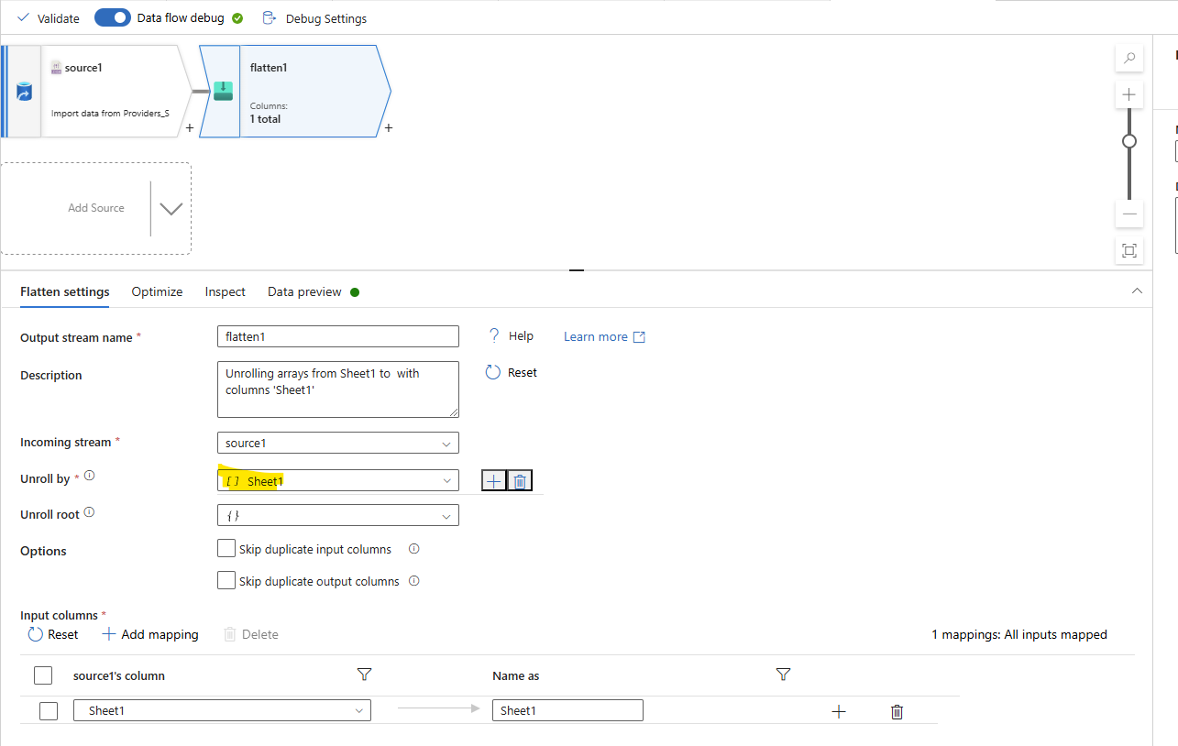

Make sure you select Unroll by : Sheet 1. And Preview data. You wil be able to fetch the records from Json

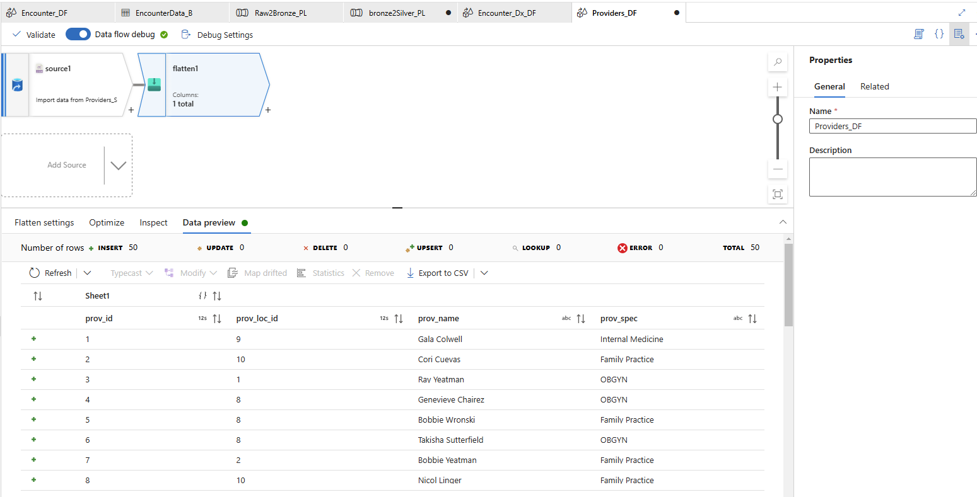

Now, we need to select the columns from sheet one. So add select activity and select the column from sheet1 and and give appropriate name. And then Sink it.

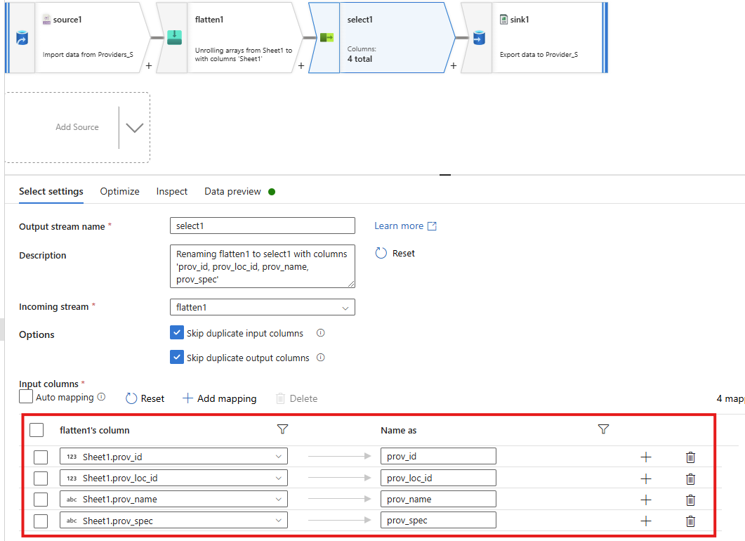

Now create Dataflow for pcp_Table.

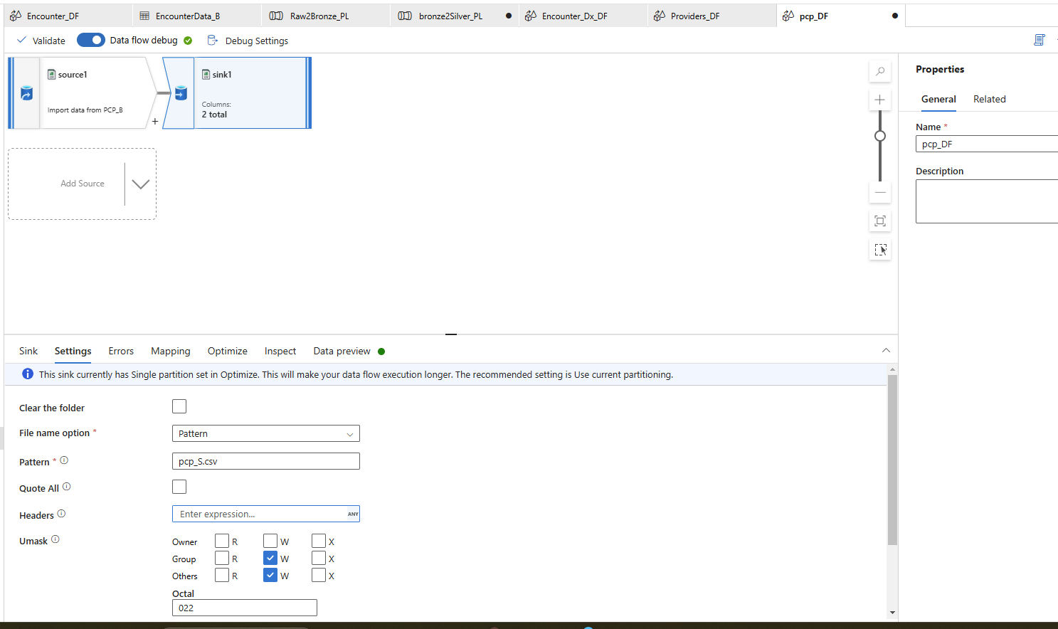

Now create Dataflow for Pregnancy_Diagnosis.csv.

Add a surrogate key in Transformation using surrogateKey

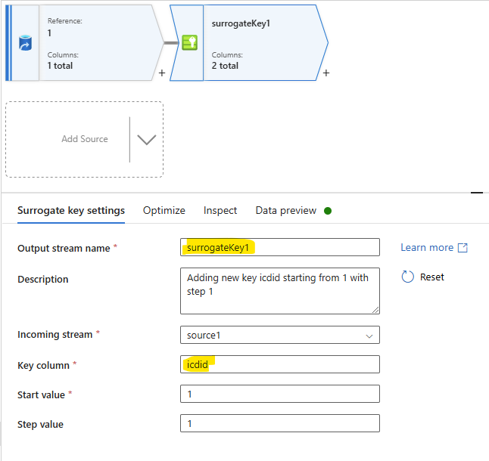

Select to order and sink it.

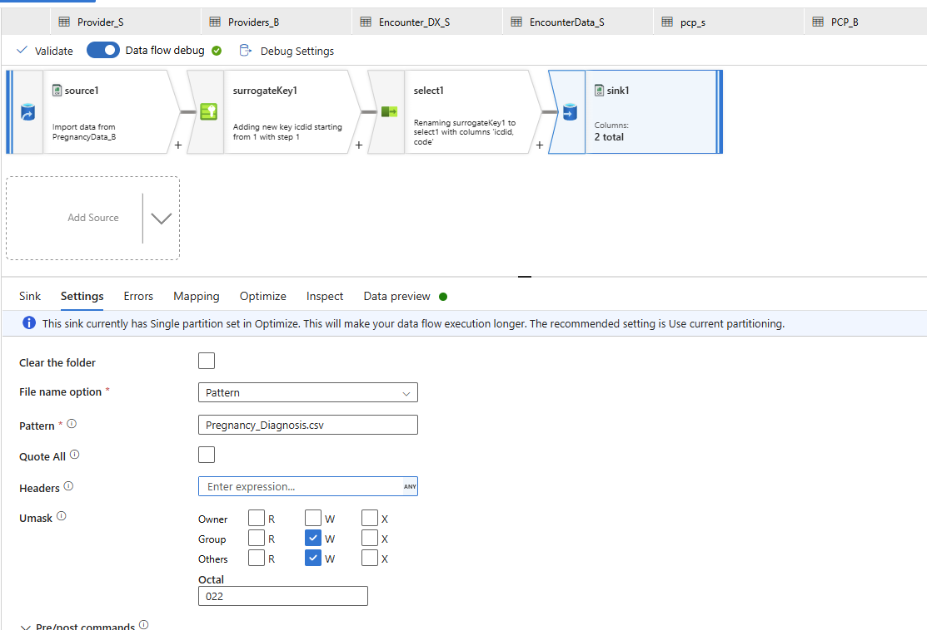

Now create data flow for Location Table.

Here we have the duplicates. To remove it we can use Aggregation

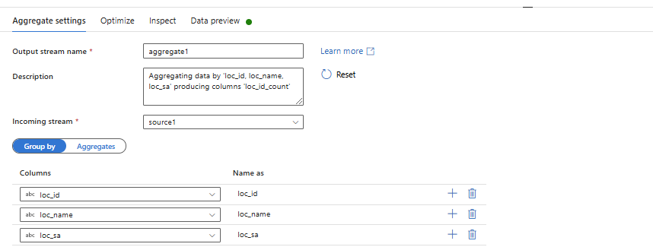

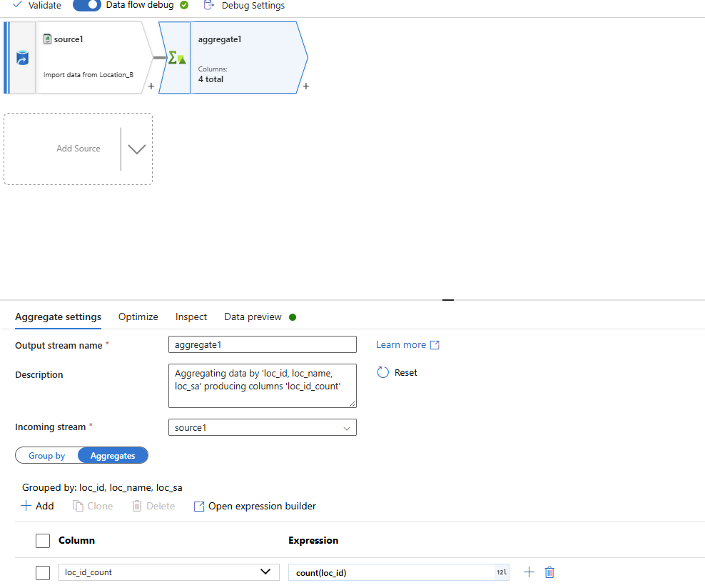

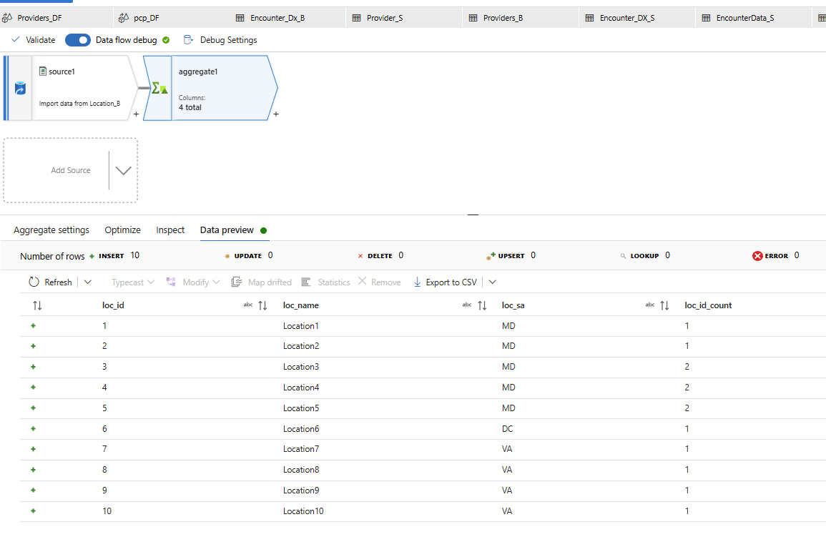

Now as we had grouped, duplicates are removed and in new column we got count. Now select only first 3 columns.

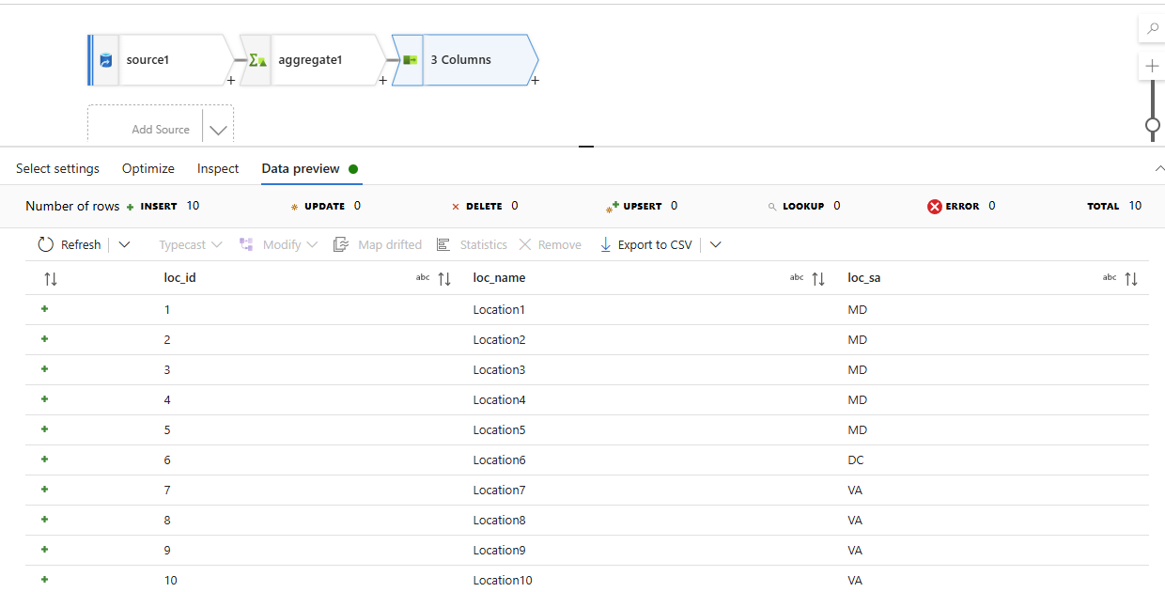

Now sink it.

Now in Total we have 6 dataflows in pipeline

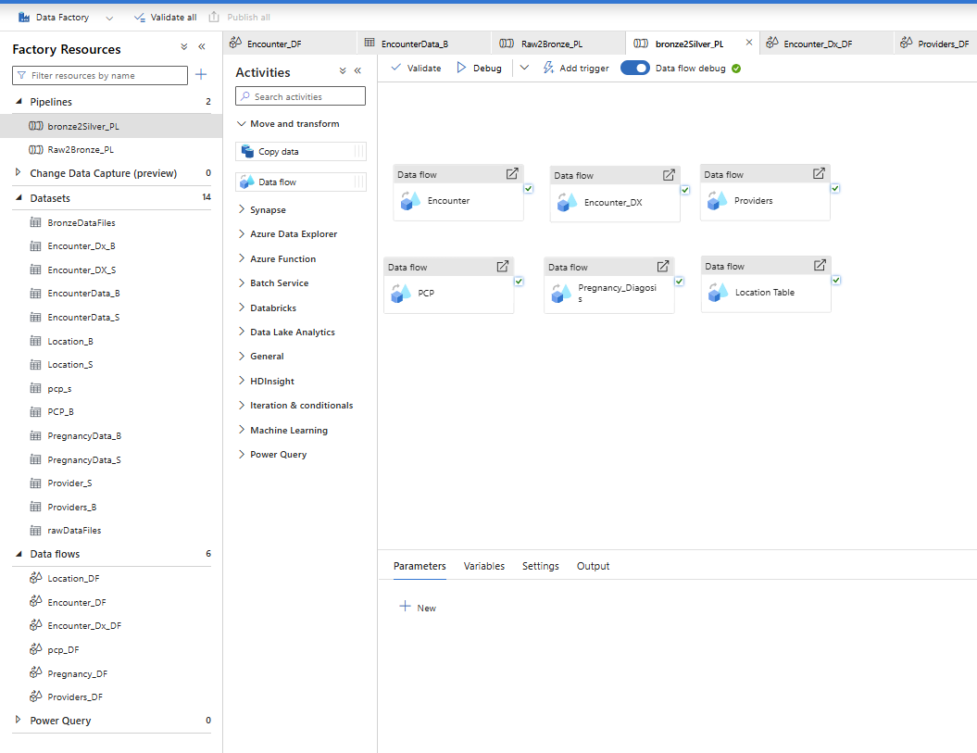

Now Trigger the pipeline.

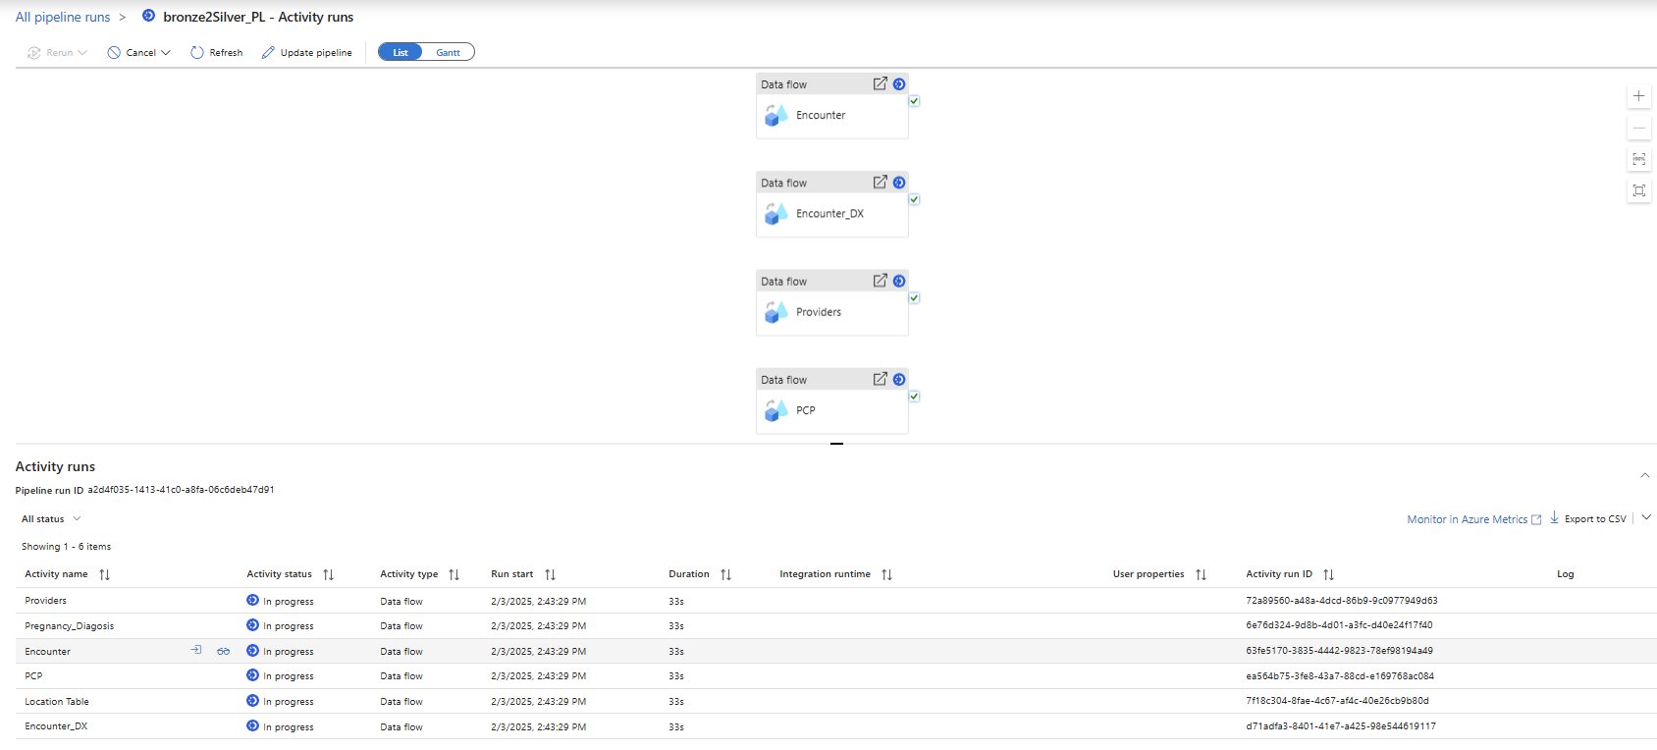

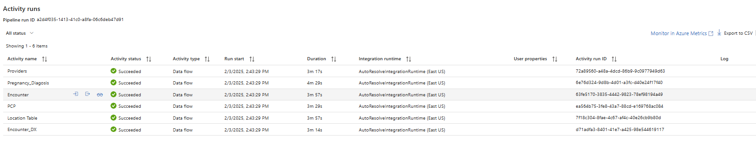

Once it is completed, Transformed file will be moved to Silver Layer.

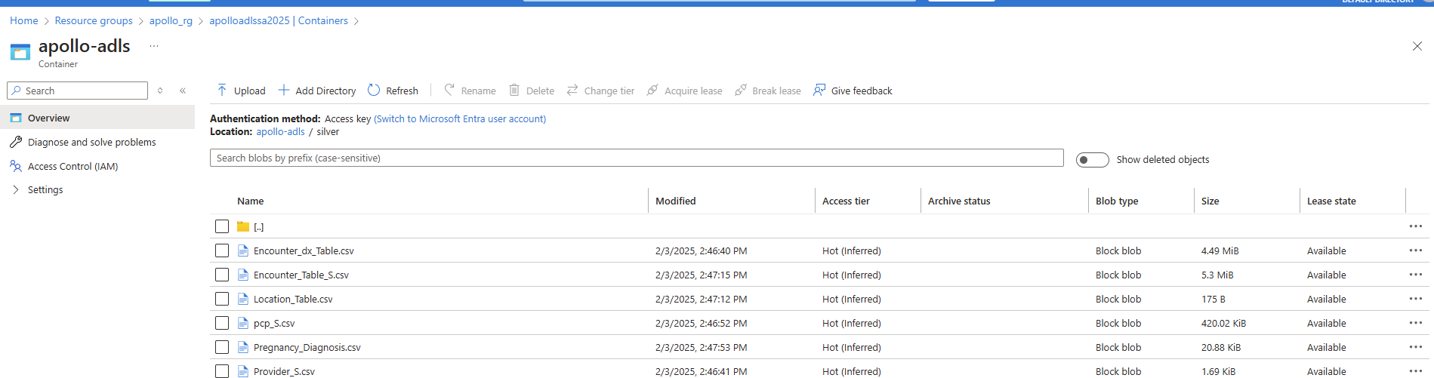

Now we need to get the data from Onprem server.

(Data Migration)

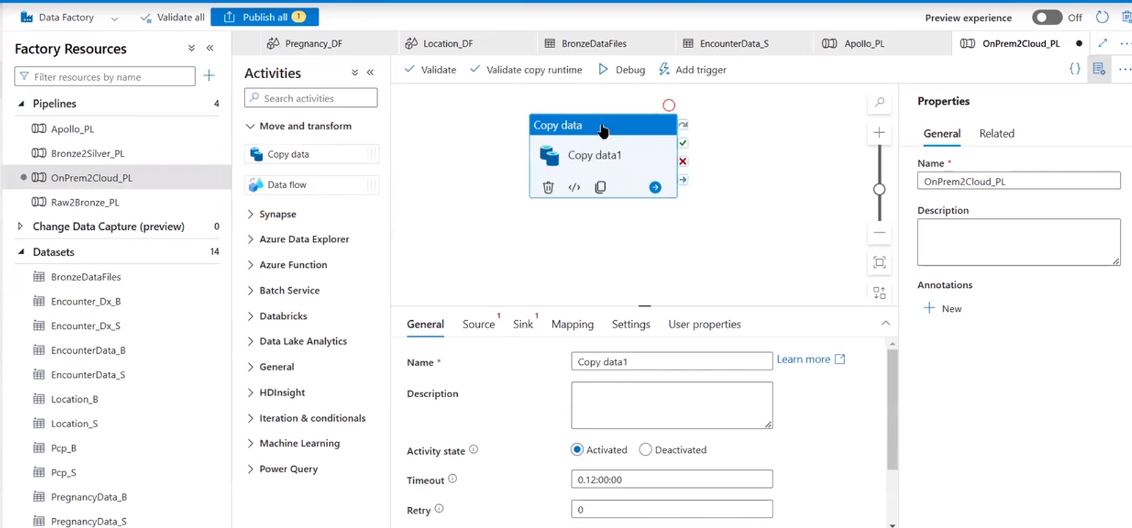

Create dataset and select Mysql.

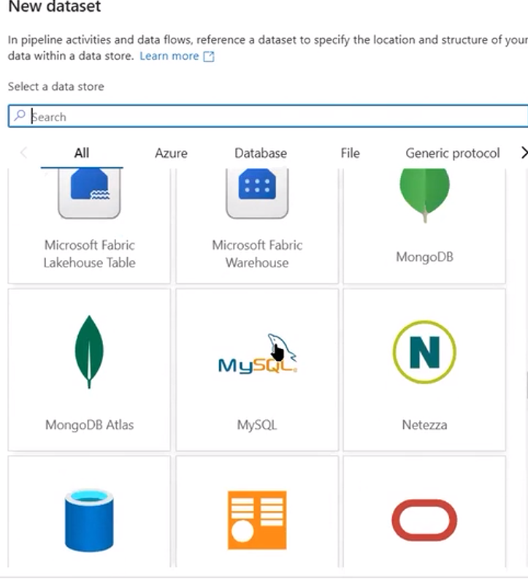

Name: OnpremData

Linked Service: As new system, new linked service need to be created.

LS name: mysqladf_LS

Server name: Localhosts

Port: 4406

Database Name: healthcare_db

Username: root

Password: Passw0rd

Integration service need to be setup on local.

In Integration runtime is compute engine. It provide infrastructure for Azure Data Factory to provide data integration capabilities.

There are 3 types of integration runtime.

1. Azure Integration runtime (default) – Moving data azure to azure

2.Self Hosted Integration Runtime (Private/onprem to Azure)

3.SSIS runtime (ssis systems)

Create New External Self Hosted Integration Runtime.

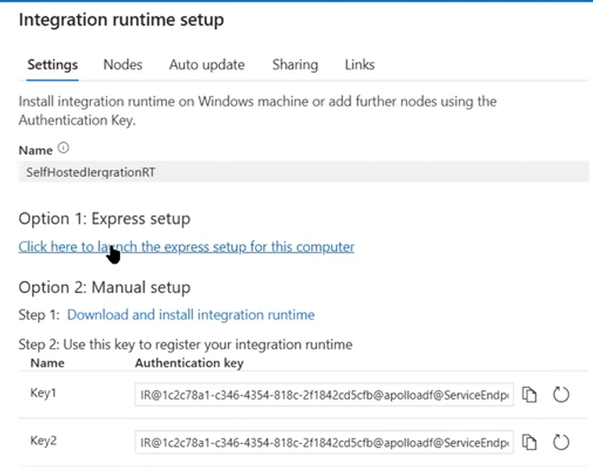

Launch express setup and install on local.

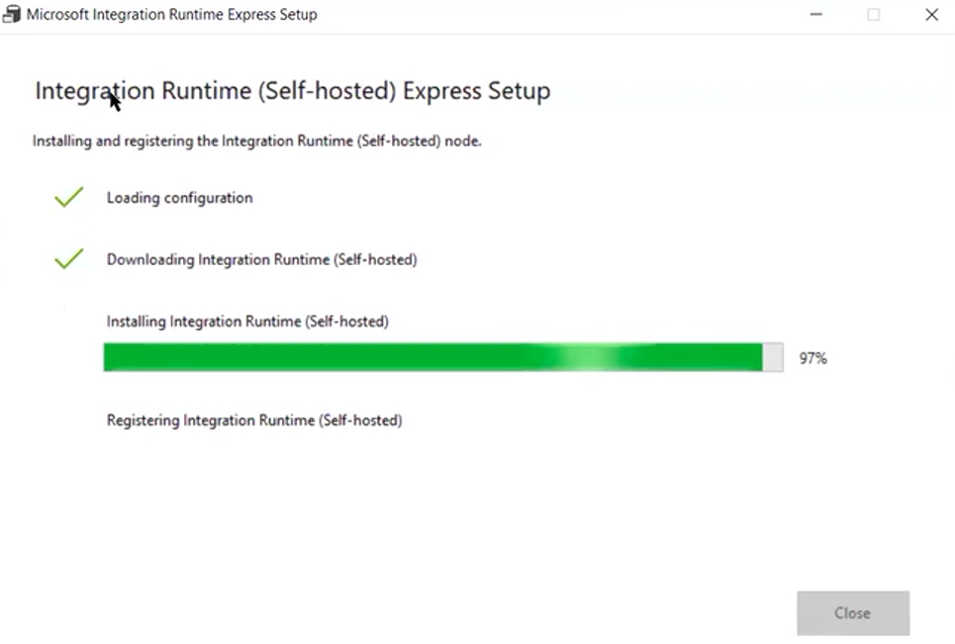

Once installed and registered. It will show in connection:

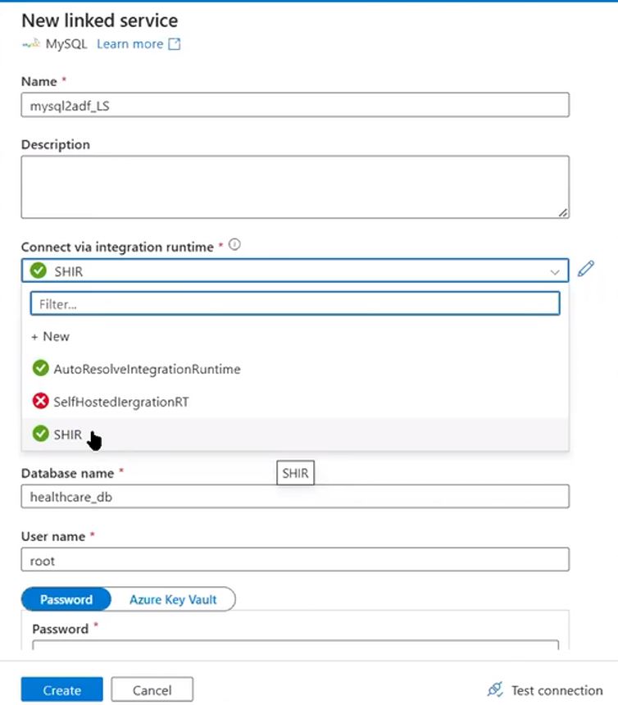

Click on create and it will ask for table

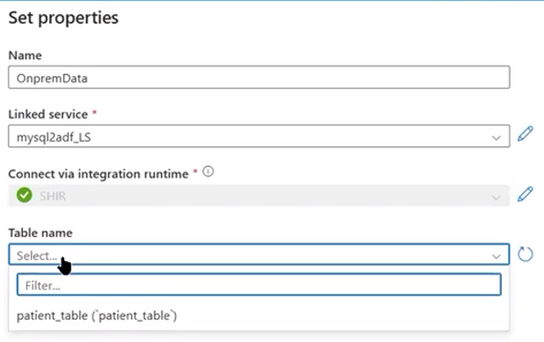

Source:

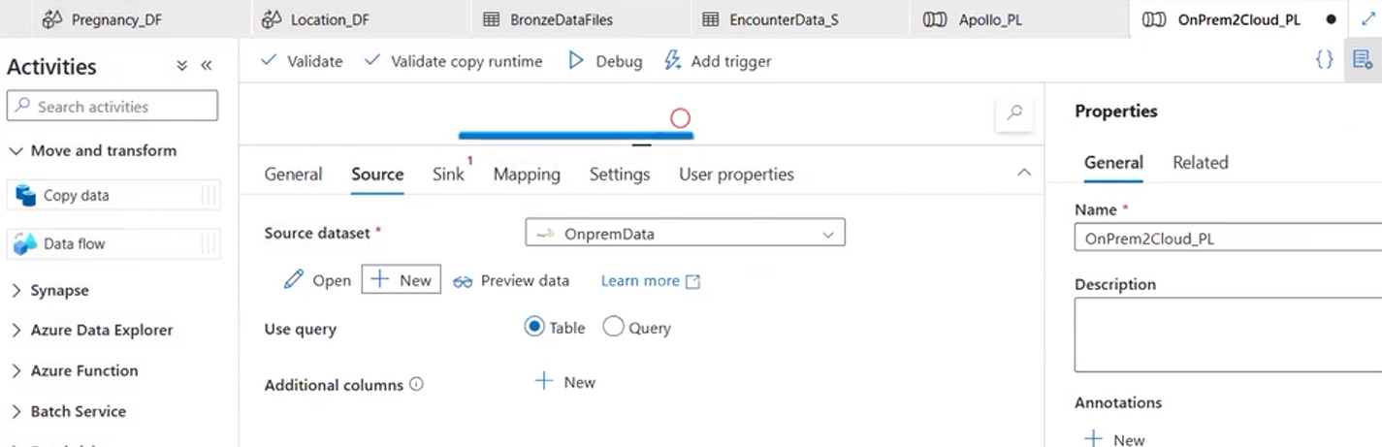

Sink:

First we will put in raw (Block Storage).

Create dataset and use ls accordingly

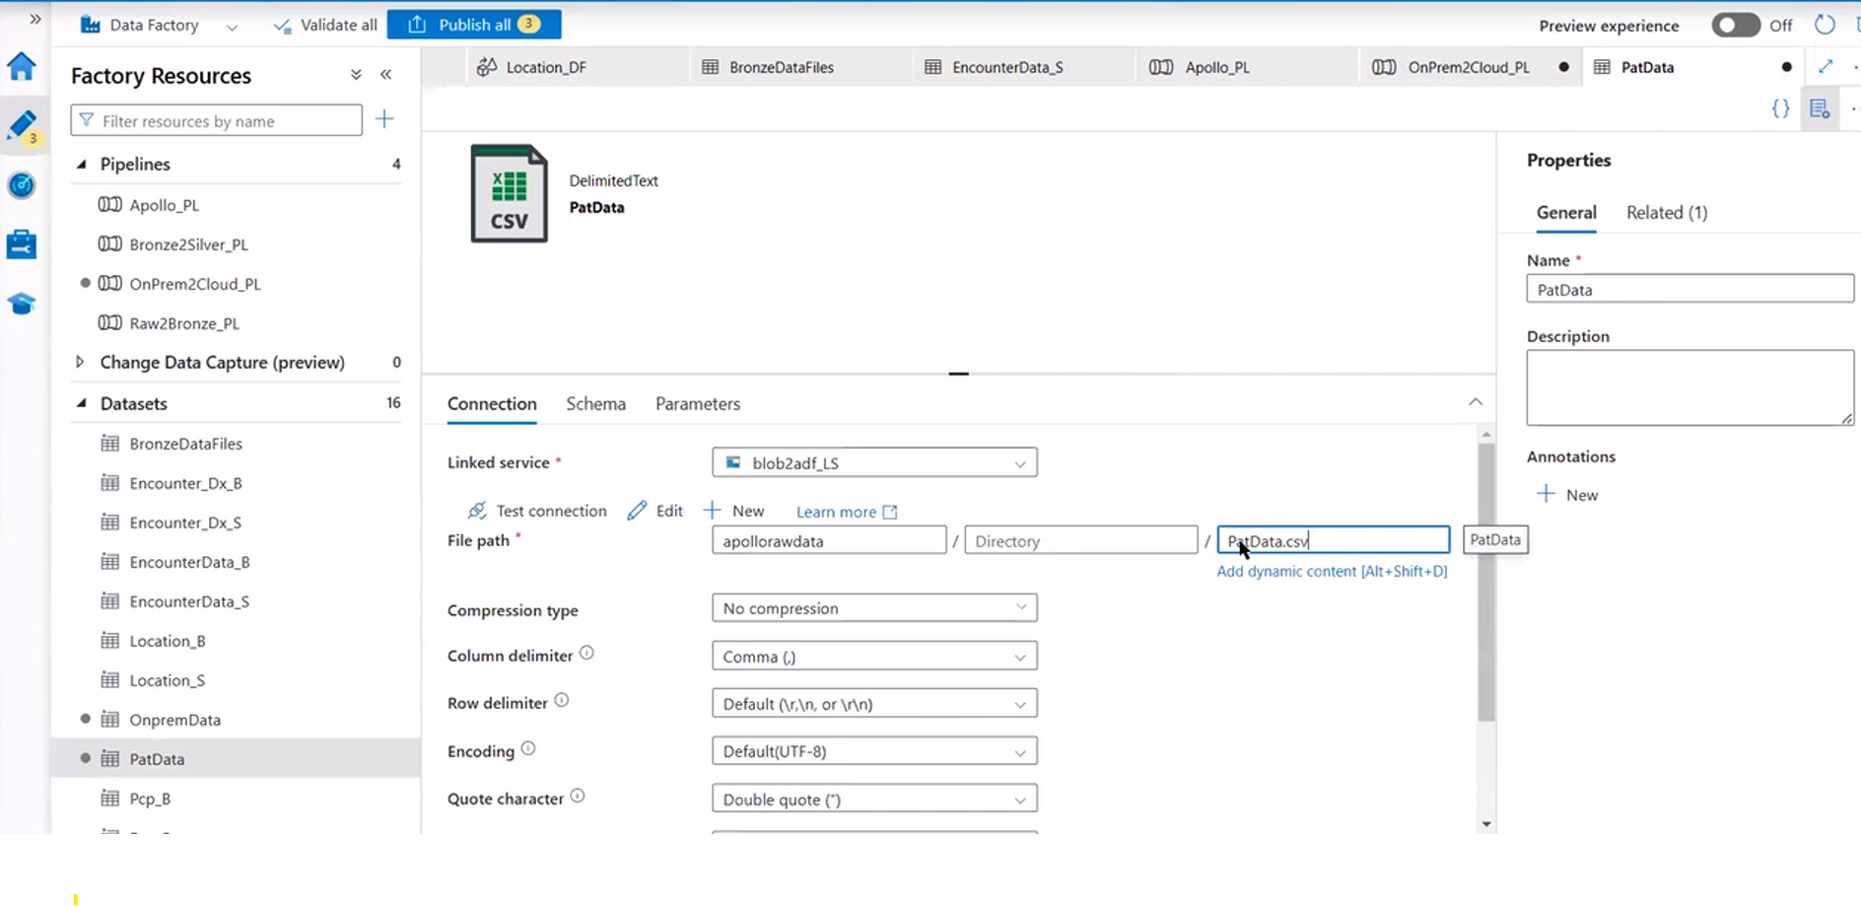

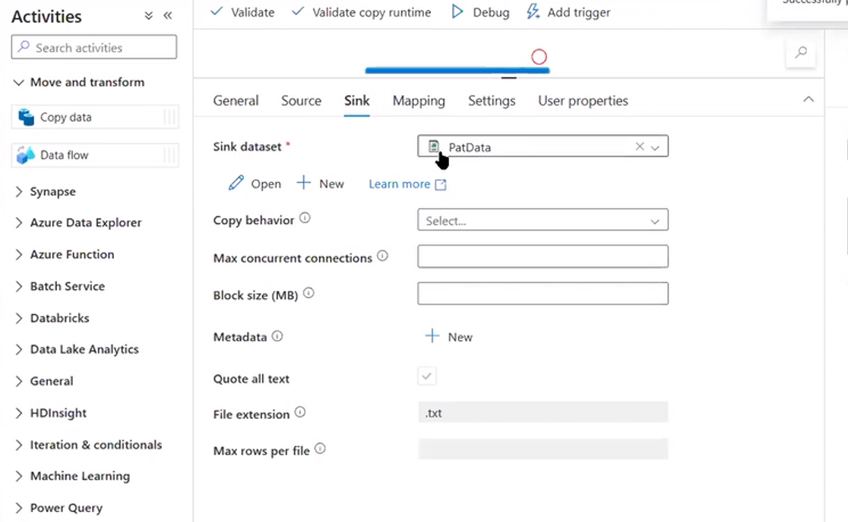

Run the pipeline. After its completion it will create file in raw blob storage account.

Now run the copy data pipeline from raw to adls.

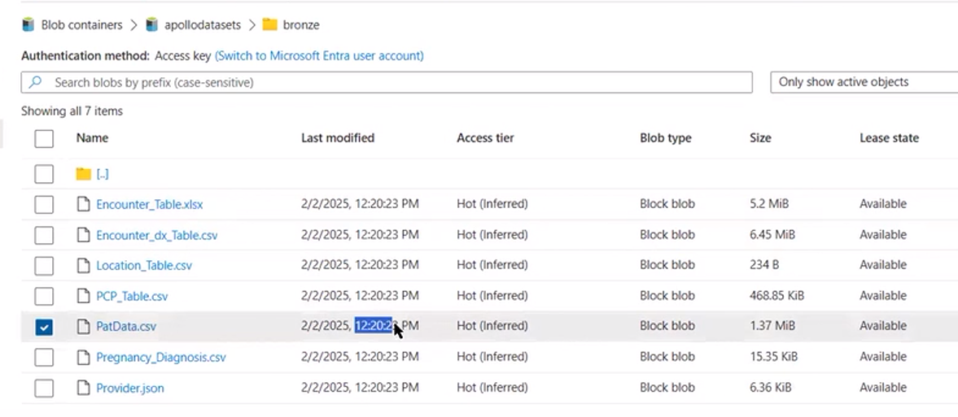

Now for pat Data, create a dataflow,

Do the transformation:

For Gender M and F, make it Male and Female

Create a derivedCoulumn activity and write a expression:

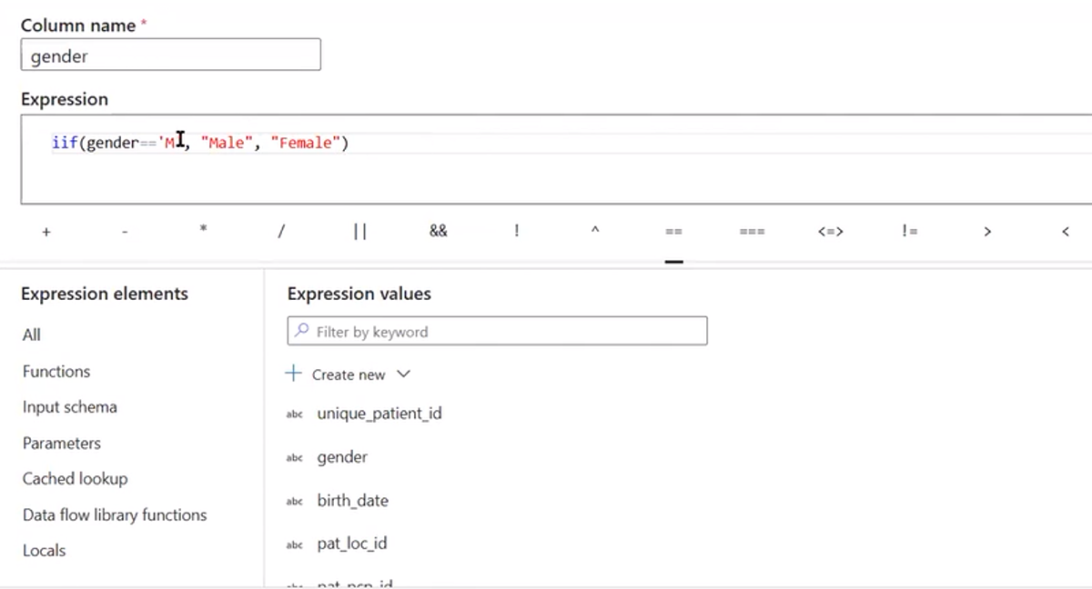

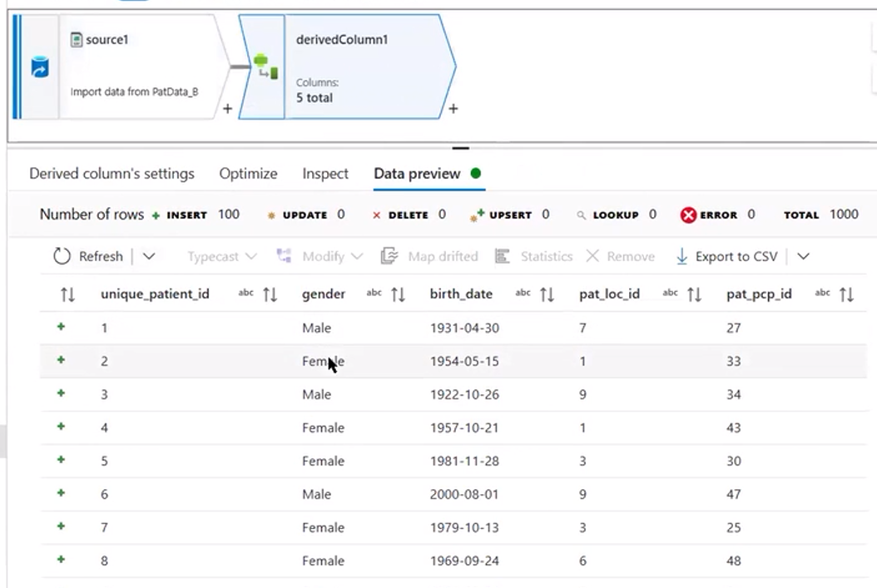

Now we will calculate the age from the date of birth column.

Add column in Derivedcolumn

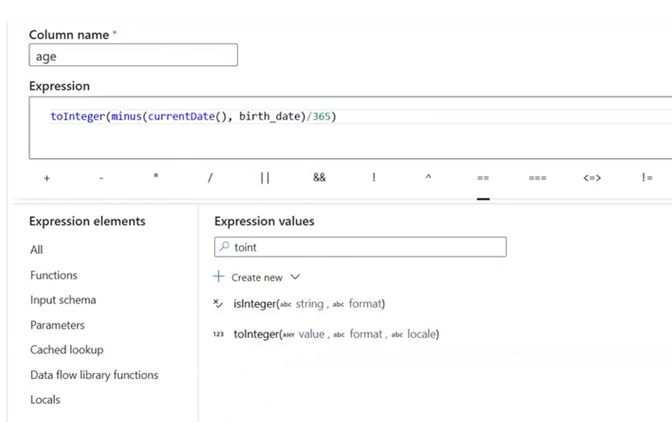

Correct the data type, then only minus will work.

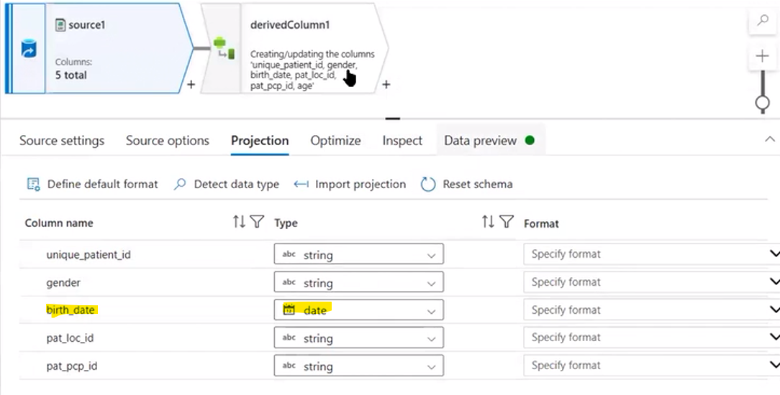

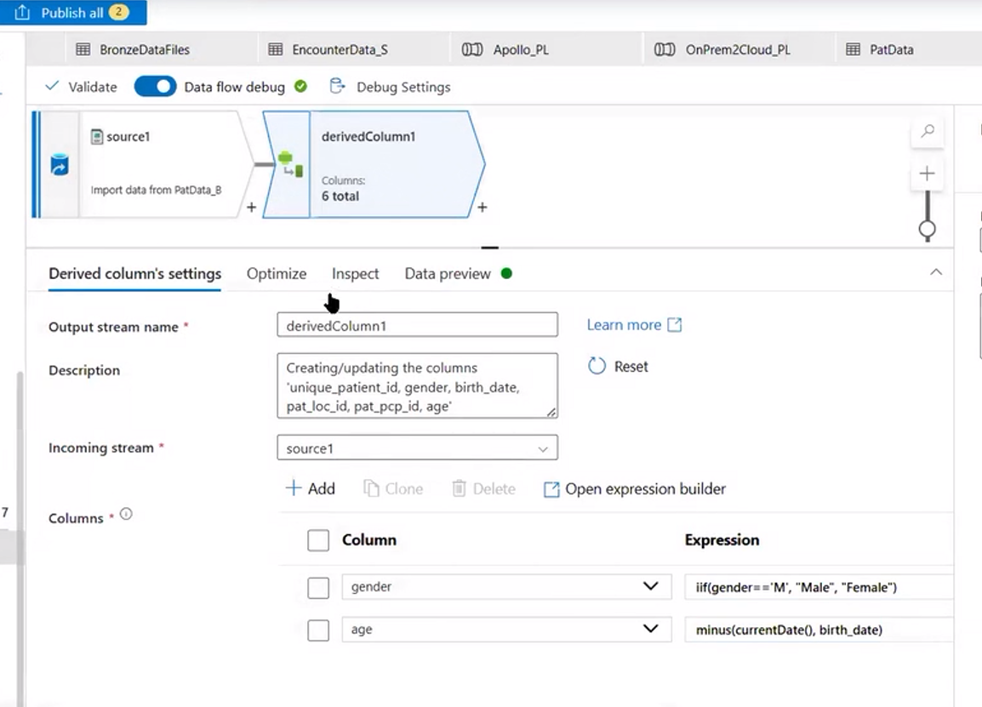

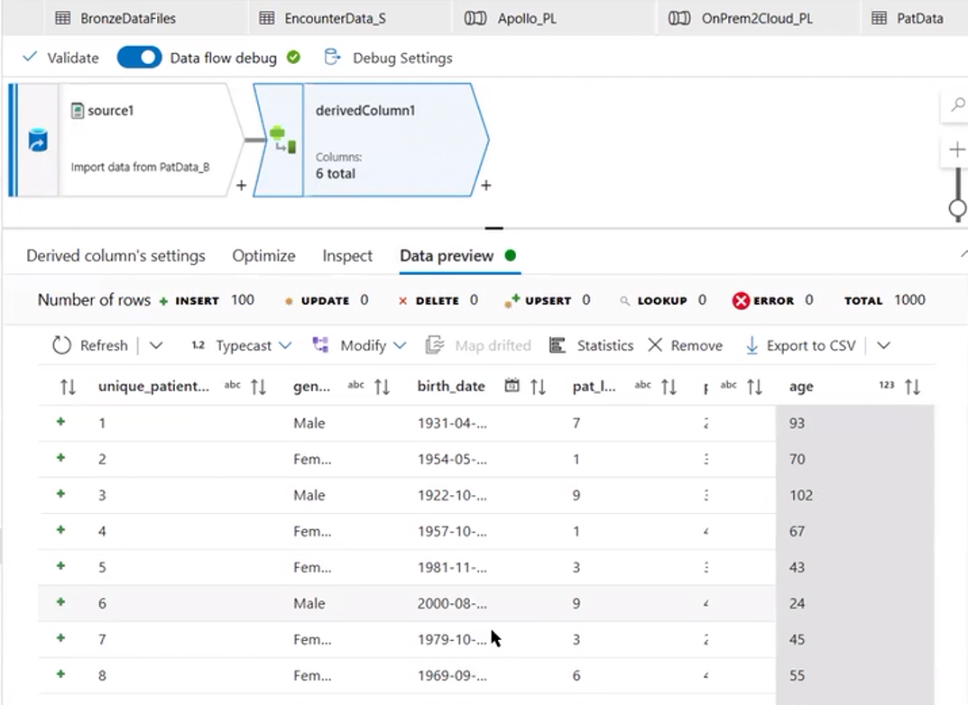

Next Activity, use select and remove the birth date

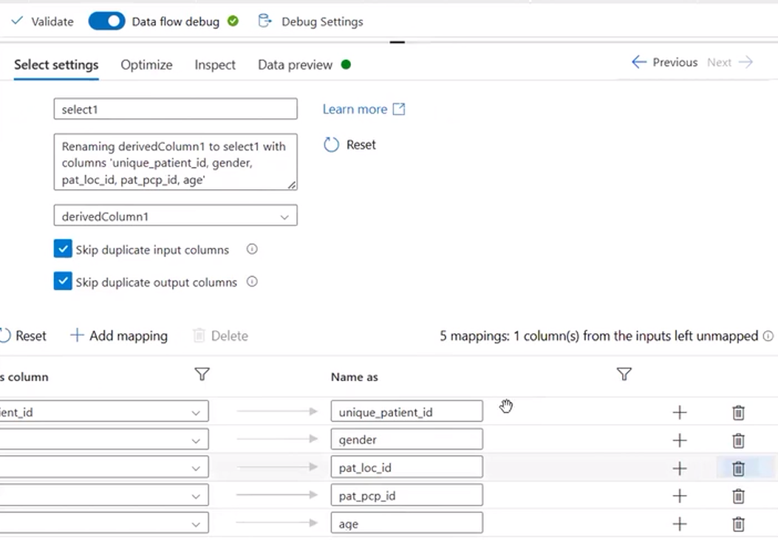

Create a sink into silver layer. Create Dataset and ls accordingly.

Lastly add the Data flow in pipeline of Bronze2Silver_DF.

Also in main pipeline add the onprem2cloud data pipeline.  
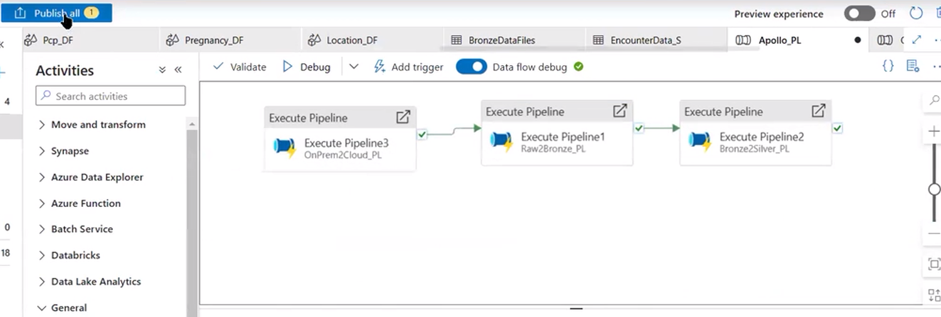

Finally, to achive the objective of project we need to join all tables and get the single source of Truth.

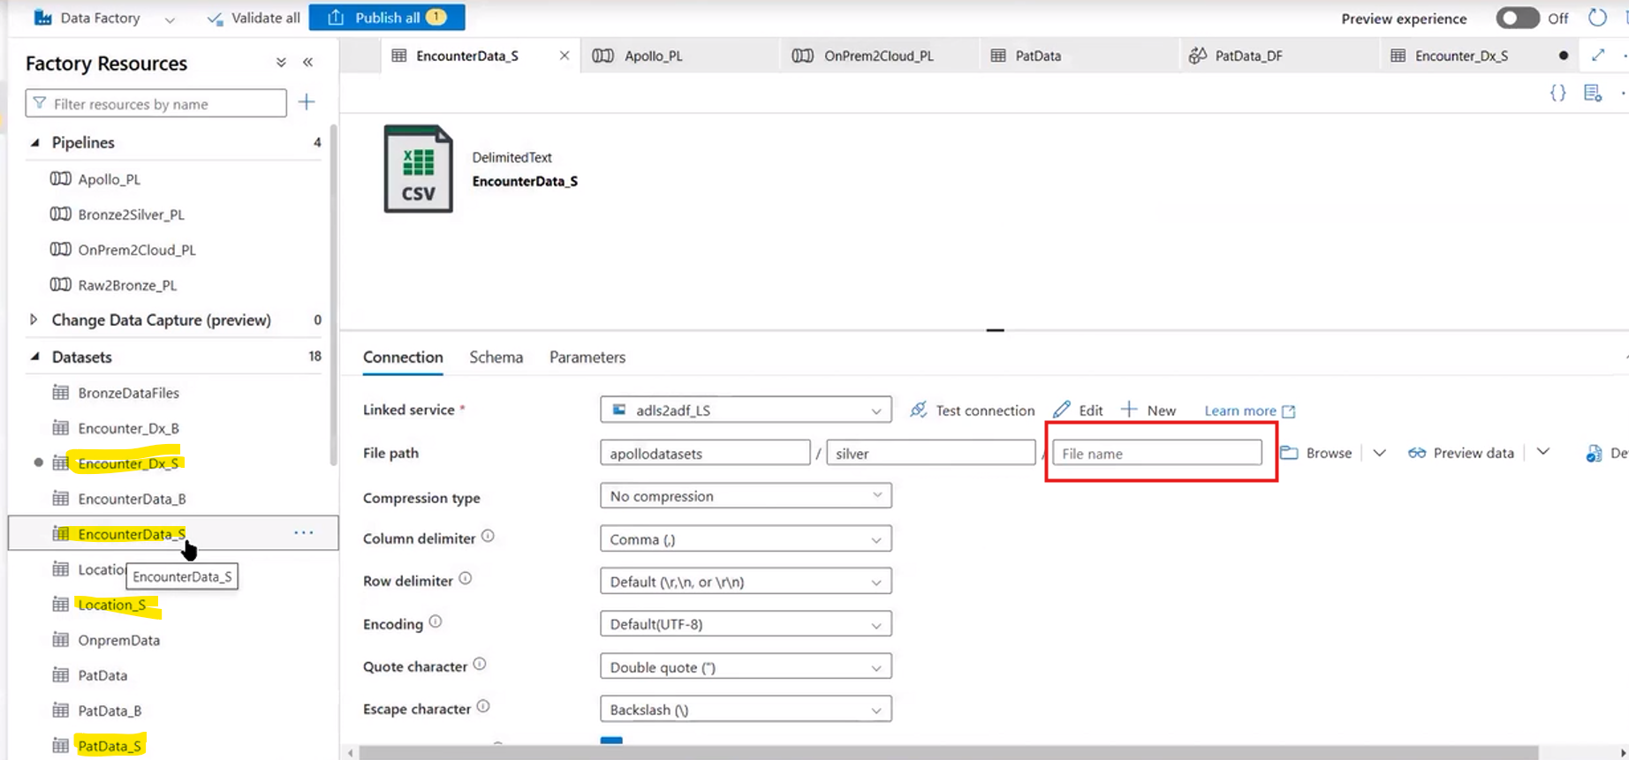

Hence update all the silver datasets with the filename as we need to fetch it and put into gold layer a single file.

Now create a main dataflow Apollo_DF, where we will do join.

